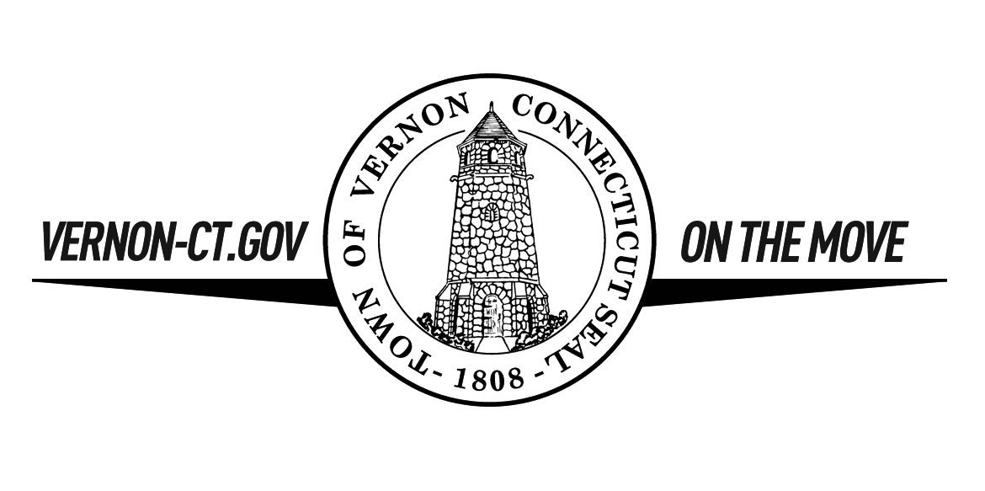
Vernon Parks and Recreation Department
120 South Street - Vernon, CT 06066
(860) 870-3520 - parksandrec@vernon-ct.gov
Facility Rental Application
TYPE OF EVENT:______________________________________Number of People Expected ____________
PLEASE PRINT
Name of Person Renting Facility________________________________DOB ________/_______/_____
^{(must be 21 or older)}
Rental is for: Individual/private event Organization/community event (certificate of insurance required)
Name of Organization ___________________________________
Address ______________________________________________________________________________
City ______________________________________State _____________ Zip Code _________________
Email _________________________________________Phone #____________________________________

RENTAL DATE : _____/_____/____ Set up and Breakdown is included in rental time
START TIME __________ AM or PM END TIME ____________ AM or PM

Facility Requested
375 Hartford Turnpike Newhoca Park Henry Park Valley Falls Park
Community Room Lodge & Pavilion Fox Hill Tower Pavilion
Gymnasium Swim Permit Picnic Grove Swim Permit
Community Pool Pavilion Bathrooms
Other Facility:____________________________ Horowitz Pool
Notes (tables/chair setup, other special requests): Bathrooms
___________________________________________
__________________________________________

By signing this I certify that I have read and understand the Town of Vernon rental policies and procedures and agree to make sure all users from the group are aware of the rules and regulations and abide by them. I understand that someone over the age of 21 must be in charge at the venue for the duration of the event and that as the rental group we are solely responsible for any and all supervision during the event. I acknowledge that I have read and understand the cancellation and refund policies, which include fees for cancellations. It is fully understood and agreed that I and anyone attending my rental event will guarantee to defend, indemnify, and hold harmless the Town of Vernon and the Vernon School Districts, its officers, employees, volunteers, and agents against any and all liabilities, claims, damages, losses, costs, and expenses arising indirectly or directly in connection with, or as a result of this agreement. It is also understood that Renting Organizations will provide and maintain insurance coverage as outlined in the rental policies and procedures.

_____________________________ _________________________________ ________________________
Printed Name of Responsible Party ^{Signature} ^{Date}

Revised May 2018

